Set of all strings of 0's and 1's such every 1 is immediately followed by a 0:
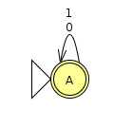Σ* automaton

Describe the complement of this language respect to the alphabet:
DEFINITION:
HOW TO BUILD?:
- Construct DFA product automatonof respective DFAs, defining final states with pairs whose state is final but whose L state is not
- Convert DFA product automaton to RE
- Construct DFA product automaton
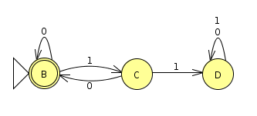L automaton
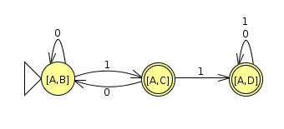Σ* x L automaton
- Convert DFA product automaton to RE
COMPONENTS:
- The ways to get from [A,B] (1) to itself without going through [A,D] (3) ()
- The ways to get from [A,B] (1) to [A,C] (2) going through all states ()
- The ways to get from [A,B] (1) to [A,D] (3) going through all states ()
REGULAR EXPRESSIONS:

